Brightening Detected in a Newborn Active Galactic Nucleus
An international team led by researchers at the Korea Astronomy and Space Science Institute (KASI) have detected a multi-year brightening event in a young active galactic nucleus (AGN) and identified the primary location where the phenomenon occurred. The team found that the brightness increase observed in the AGN known as 3C 138 originated from the radio core near the galaxy’s center and was likely linked to an increased supply of high-energy electrons, rather than to a stronger magnetic field.
The object observed by Dr. Sang-Sung Lee’s research team at KASI, 3C 138, is classified as a Compact Steep Spectrum (CSS) source — a young AGN whose radio structure is still compact enough to remain confined within its host galaxy. CSS sources typically exhibit spectra in which brightness rapidly decreases at higher radio frequencies and usually show little variability in radio emission.
Although CSS sources are generally stable in radio brightness, 3C 138 began to show a significant increase in radio emission since 2022. Enhanced gamma-ray activity and increased X-ray emission were also reported afterward, raising the need to determine the origin of the brightening. In particular, researchers sought to identify whether the event occurred in the radio core or in a more distant jet structure.
Radio spectral studies suggest that the jet activity in 3C 138 occurs on a timescale of tens of thousands of years. Compared to the Sun’s age of about 4.6 billion years, the source can be regarded as a “newborn baby” on cosmic timescales. Its radio jet extends only about 10,000 light-years, meaning it is still in a stage where strong interactions with material in the host galaxy are likely. In contrast, jets from fully evolved radio galaxies can extend hundreds of thousands or even millions of light-years.
Using observations from the Karl G. Jansky Very Large Array (VLA) and the Very Long Baseline Array (VLBA) in the United States, the team confirmed that the compact radio core of 3C 138 became approximately 2.6 times brighter between 2022 and 2025. In contrast, nearby compact structures and more distant jets showed no significant increase in brightness.
To investigate why the radio core brightened, the researchers conducted simultaneous observations of 3C 138 in four radio-frequency bands using the Korean VLBI Network (KVN). Because the radio core changes rapidly, observing at different frequencies at the same time is essential for accurate analysis.
The observations revealed that the radio core exhibited an unusual spectrum in which brightness increased again at certain frequencies — unlike the typical spectra of CSS sources. The researchers interpreted this feature as synchrotron self-absorption (SSA), a phenomenon in which low-frequency radio waves are reabsorbed within a very dense region.
Through SSA analysis also including archival data from Atacama Large Millimeter/submillimeter Array (ALMA), the team estimated the magnetic field strength inside the radio core. The results showed that the magnetic field was weaker than expected, while a large number of high-energy electrons had recently been injected into the region. This suggests that the brightening is consistent with enhanced particle injection/acceleration rather than requiring magnetic-field amplification. These accelerated particles can also boost surrounding photons to much higher energies, potentially explaining the simultaneous increase in X-ray and gamma-ray activity.
Shan Li, a researcher at KASI and the University of Science and Technology (UST) and the first author of the study, said, “This study shows where brightening events occur in young active galactic nuclei and what physical processes drive them. It provides important clues for understanding how jet activity is enhanced in these young systems.”
Dr. Sang-Sung Lee of KASI added, “Our findings demonstrate that even in CSS sources, central jet activity can be linked to X-ray and gamma-ray emission, similar to what is observed in more evolved AGNs. This highlights the importance of simultaneous multi-frequency VLBI observations and may contribute to future studies of jet evolution and the origin of high-energy emissions in young AGNs.”
The study was published in the June 5, 2026 issue of Astronomy & Astrophysics.

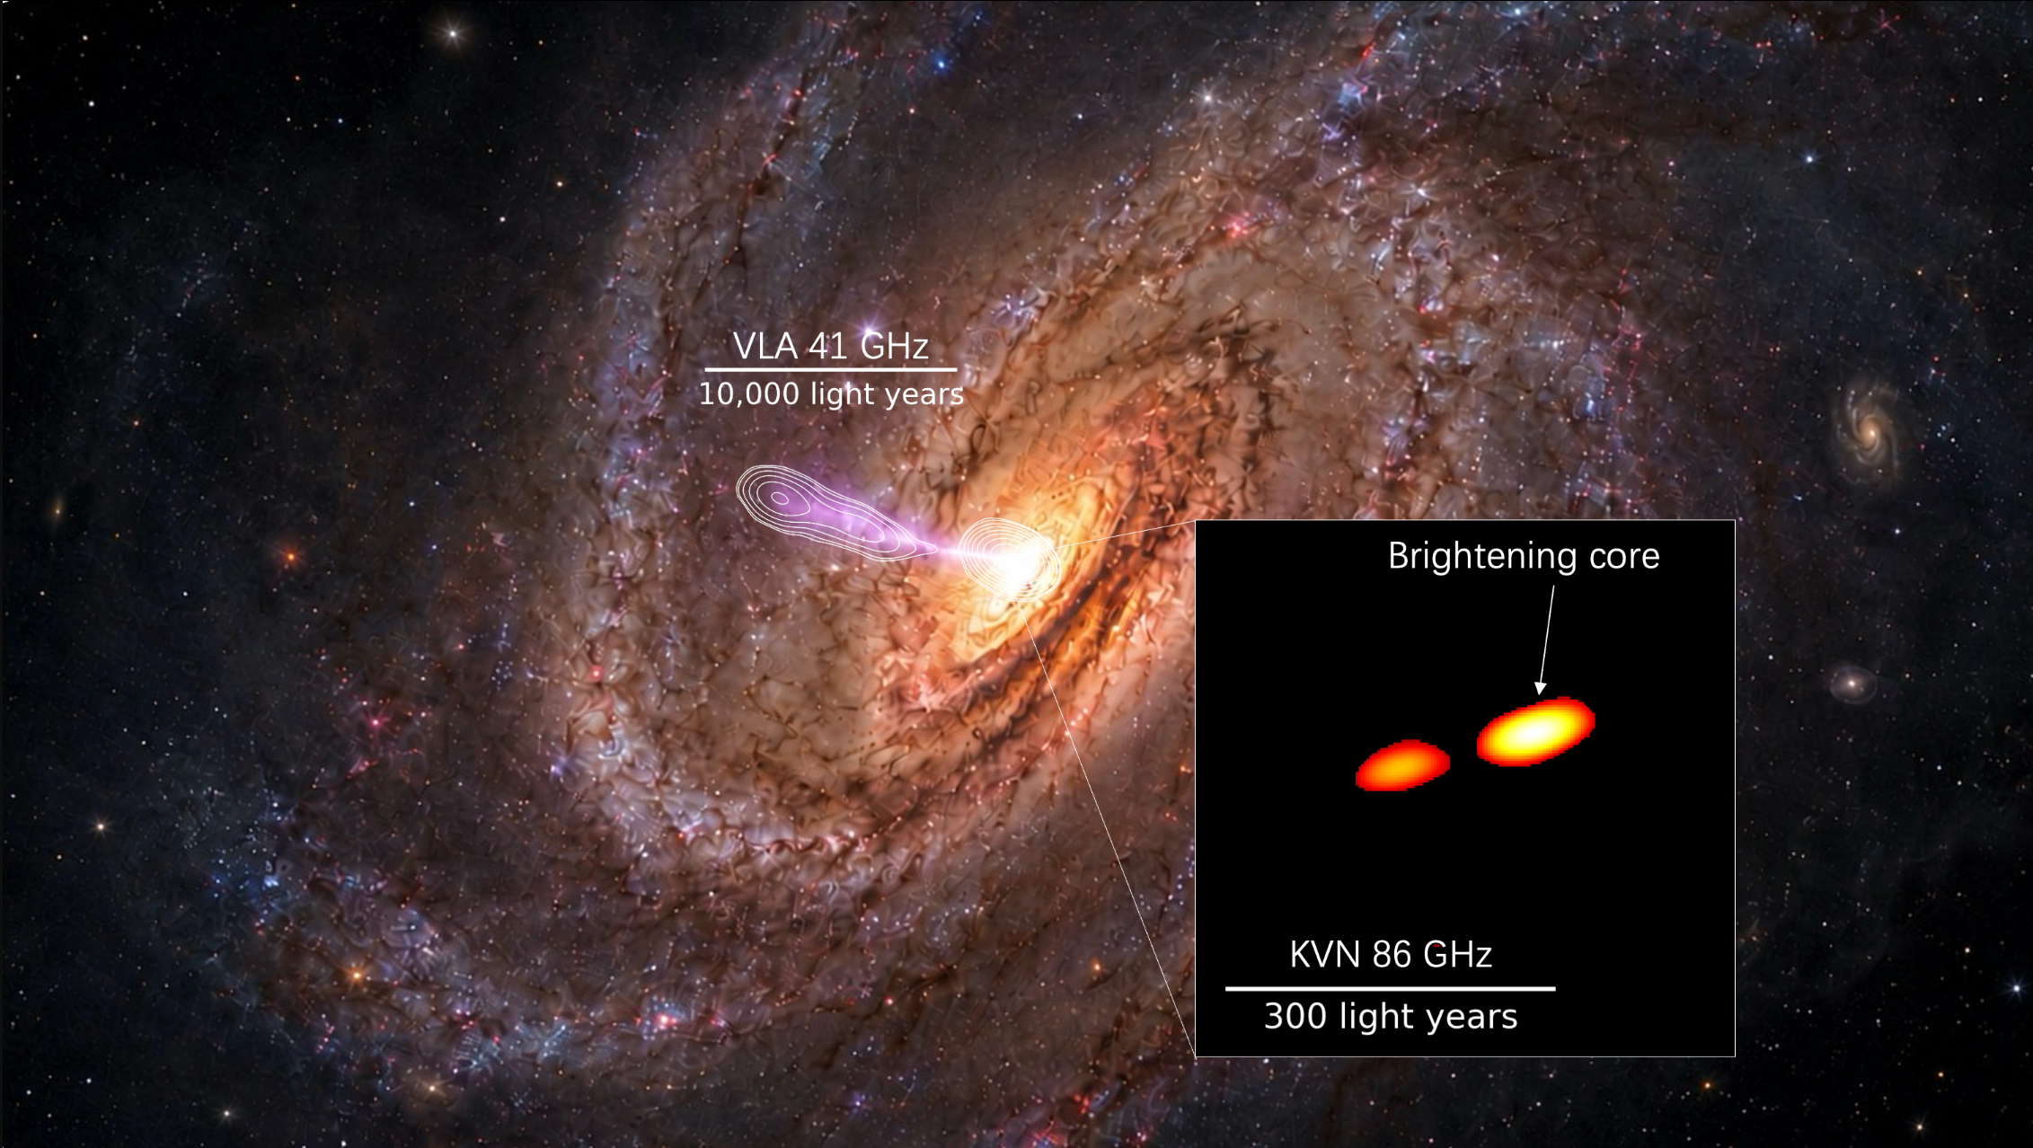
Figure 1. Schematic illustration of the radio jet structure of the young active galactic nucleus 3C 138. The background galaxy image is an artistic illustration rather than an actual observation. Overlaid are radio jet contours from VLA 41 GHz observations and an enlarged view of the core region from KVN 86 GHz observations.
_________________________________________________________________
Media Contacts:
KASI
Sang-Sung Lee +82-42-865-2177 sslee@kasi.re.kr
KASI & UST
Shan Li +82-42-865-5883 shan_li@kasi.re.kr

